Contents
  - Abstract................................................................................................................p4

2.1 Literature Review.................................................................................................p5
2.2 Lower respiratory tract infections in children with neurological impairment........p5
2.3 Chest physiotherapy............................................................................................p5
2.4 Passive chest physiotherapy...............................................................................p6
A. Modified postural drainage.........................................................................p6
B. Percussion..................................................................................................p7
C. Chest wall vibrations..................................................................................p7
2.5 Active cycle of breathing technique.....................................................................p9
2.6 Rebound Therapy................................................................................................p9
2.7 Cardiorespiratory response during rebound therapy.........................................p10
2.8 Conclusion.........................................................................................................p11

3.1 Research Question............................................................................................p13

4.1 Justification for the study...................................................................................p14

5.1 Rationale............................................................................................................p16

6.1 Aims for the proposed study..............................................................................p17

7.1 Research Design and Methodological Approach...............................................p18

8.1 Research Protocol.............................................................................................p20
8.2 Subject selection and recruitment.....................................................................p20
8.3 Inclusion and Exclusion Criteria........................................................................p21
8.4 Sampling size....................................................................................................p23
8.5 Subject consent.................................................................................................p23
8.6 Data collection tools...........................................................................................p23
8.7 Data analysis.....................................................................................................p24
8.8 Limitations to the study......................................................................................p24
9.1 Ethical Considerations.......................................................................................p26
10.1 Time-frame and cost........................................................................................p27
10.2 Table of events................................................................................................p27
10.3 Expenses.........................................................................................................p27

11.1 Possible projected Outcomes..........................................................................p29

12.1 References......................................................................................................p30

13.1 Glossary...........................................................................................................p34

14.1 Appendices......................................................................................................p35

  - Abstract
Lower respiratory tract infections are the primary cause of death in paediatrics with the most severe form of cerebral palsy. Currently the only physiotherapy treatments available to this population are passive; however, literature suggests rebound therapy has potential for also being an effective sputum clearance technique. Rebound therapy is currently available in 45% of special needs schools and is of growing clinical interest. Patient positioning and movement of the trampoline bed during rebound therapy appear to imitate essential elements of conventional chest physiotherapy, namely modified postural drainage and forced expiration. In addition, rebound therapy stimulates an exercise response and utilises active cycle of breathing technique. Both of these validated airway clearance methods are usually difficult to utilise in paediatrics with such physical limitation and cognitive issues. Not only does rebound therapy therefore take advantage of more techniques, but it could also be the first active-assisted airway clearance method for this population. A comparison of net sputum weight collected from conventional treatment and rebound therapy over a 6month pilot study with 10children, would begin to determine whether rebound therapy could be used as a chest clearance technique in the future.

2.1 Literature Review
2.2 Lower respiratory tract infections in children with neurological impairment
Cerebral palsy (CP) is a non-progressive, but not unchanging, neurological disorder caused by an insult to an immature brain. It results in motor impairments affecting posture and movement, and in some cases associated epilepsy and or learning difficulties. The Gross Motor Function Classification System (GMFCS) (Palisano et al, 2007) defines five levels of functional ability and limitation for people with CP. GMFCS V represents the most severe limitations, indicating that self initiated movement is extremely restricted (14.1A).
Lower respiratory tract infections (LRTI) are the primary cause of death in children with CP GMFCS V (Calis, 2011). This is because of respiratory muscle weakness and secretion retention due to reduced mobility, as well as a poor cough and airway, recurrent aspiration and kyphoscoliosis (Seddon and Khan, 2003). The NHS (2011) defines a LRTI as inflammation of the airways and pulmonary tissue due to a viral or bacterial infection, which is associated with a cough. It can be diagnosed using a GPs examination of the cardiorespiratory system, including temperature, heart rate, blood pressure, oxygen saturations, respiratory rate, chest auscultation, and in some cases sputum analysis (Willacy, 2012). Usually patients are recommended to increase their fluid uptake and are prescribed pain relief. However, LRTIs in a child with severe CP can have an impact on eating, drinking, seizures and tone. Therefore target, broad-spectrum antibiotics and intensive chest physiotherapy is also required (Jamroz et al, 2011) to prevent rapid deterioration of their health.

2.3 Chest Physiotherapy
Chest physiotherapy improves respiratory efficiency by promoting lung expansion, strengthening respiratory muscles, and eliminating secretions from the respiratory system. It encompasses active, assisted and passive techniques including active cycle of breathing, modified postural drainage, percussion and vibration. According to Wallis, Prasad (1999) and Hough (2001), manual passive techniques can be extremely useful for paediatrics with learning difficulties, exhaustion or musculature weakness due to neurological impairments. The physiotherapist is able to assist the respiratory system in this group of children, who are often unable to perform independent techniques.
It has been argued by Seddon, Khan (2003) and Schechter (2007) that daily chest physiotherapy should be given as a preventative measure to CP patients with recurring LRTIs. Both literature reviews acknowledge the impact LRTIs can have on quality of life. Their philosophy suggests that maintaining clear bronchial airways reduces secretion retention, and hence the risk of bacteria causing infection. However, despite this knowledge, evidence supporting daily chest physiotherapy is extremely limited and mainly anecdotal (McCool and Rosen, 2006). There are currently no NICE guidelines recommending it (NICE, 2012) so intensive, passive chest techniques are common practice from the onset of an LRTI.

2.4 Passive chest physiotherapy
Modified postural drainage, percussion and vibrations are the passive techniques commonly used for children with severe CP (Fitzgerald et al, 2009). Although studies have documented our understanding of their mechanics, and their role within chest physiotherapy, very few have directly related this to children with severe CP. One preliminary study considered the use of spectrogram analysis to evaluate the effectiveness of chest physiotherapy in 2severe CP patients (Toshihiro et al, 2000). It documented that passive techniques had improved breath sound clarity and removed bronchial mucus. However the study’s extremely small scale and lack of objective outcome measures limits this study’s validity. In addition, technique, frequency and duration were not considered in this small scale study. Therefore it can only confirm chest physiotherapy was beneficial in these subjects but cannot clarify whether it was modified postural drainage, percussion or vibration that had specifically aided them.

- Modified postural drainage
Modified postural drainage (MPD) is an adaptation of postural drainage to no longer consist of a head down tip. It works on two principles; firstly, any change in position alters ventilation distribution and may aid in the circulation of air behind sputum to aid in it’s removal. Secondly, positions utilise gravity and lung physiology to manipulate mucus transport towards larger airways (14.1B)
- Percussion
Also known as chest clapping, percussion is applied to the patient’s chest in a rhythmic ‘clap’ using a cupped hand and loose wrist (Hough, 2001). Energy waves are transmitted through the airways and loosen secretions from the airway wall (14.1C).

- Chest wall vibrations
According to McCarren et al (2003) vibration is the application of a fine oscillatory movement combined with chest wall compression. The rapid compressive force and vibratory action follows the normal direction of the ribs during patient expiration and transmits through the chest wall (Pryor and Prasad, 2008). Vibrations increase forced expiratory flow rates (FEFR) and also augment mucus transport by decreasing viscosity (King et al, 1983. McCarren and Alison, 2006). Secretions are moved towards bronchi making removal via cough or suctioning easier (14.1D).

Bateman et al (1981) reported that chest physiotherapy as an adjunct to coughing was beneficial in order to clear secretions. They found that it was the combination of MPD, vibrations, percussion and a cough that accelerated central and peripheral lung clearance whereas a cough alone only enhanced central lung clearance. This is relevant to patients with severe CP and a LRTI, as their secretions also accumulate in peripheral lung regions. Passive chest physiotherapy was administered for four minutes every five minutes for twenty minutes. The minute rest was to allow the patient to cough which resulted in an average of 5g more sputum being obtained than in coughing alone. This study provides evidence to support the need for chest physiotherapy consisting of all four components, MPD, percussion, vibration and FEFR in children with severe CP.
In contrast, Stiller et al’s (1996) study suggested that vibrations had not contributed to more efficient secretion removal despite being administered for 20minutes hourly over 6hours. The study compared airway clearance using suctioning with and without the addition of postural drainage, MPD and vibrations. They concluded that MPD was the most useful component when suctioning a patient. Although the study was completed in intubated subjects with acute lobar atelectasis, children with severe CP undergo the same passive chest physiotherapy and suctioning due to their physical and cognitive limitations. Therefore, much like Bateman’s study, it is reasonable to hypothesise that the MPD element may also elicit a positive physiology response in subjects with severe CP.
To further investigate the effectiveness of vibration during chest clearance, McCarren et al (2006) analysed the components of chest wall vibration. The study also disagreed with Stiller (1996) arguing that vibration does play an important role in the removal of secretions. It was documented that the combination of oscillation and chest wall compression achieve up to 50% higher FEFR than oscillation or compression independently. Interestingly, the study also recommended that deep breaths are not taken prior to the application of vibration as it can cause an inspiratory bias. This means that the FEFR is less than inspiratory and cannot therefore be expected to remove secretions. Unfortunately, the study was conducted in a healthy adult subject and would need to be trialled in a larger population who have sputum retention difficulties in order to be validated. Measuring sputum production as well as FEFR would further confirm the study’s claims. However, it does suggest that vibrations would be a suitable technique for children with severe CP, who due to cognition and respiratory muscle weakness, are unlikely to independently accomplish greater FEFR.
Percussion too has been under much debate with regards to its effectiveness in the removal of bronchial secretions. Gallon (1991) recorded that the addition of percussion to MPD and forced expiration increased the rate of sputum production by 1.2g/min in patients with copious amounts of sputum. According to Van der Schans et al (1999) percussion achieves increased sputum clearance as it stimulates a cough through the loosening and movement of mucus. Previously percussion had been reported as having non-significant effects under the same conditions (Sutton et al, 1985. Van de Schans et al, 1986) so it appears that MPD over postural drainage, and the increased force at which percussion is now applied, is responsible for this change. All of the studies documented the value of percussion with patients who have difficulties removing secretions, either due to their inability to independently move or because they had a poor cough. This fits the profile of someone with severe CP which leads us to believe that percussion is, as Bateman suggested, an important contribution during chest physiotherapy.

2.5 Active cycle of breathing technique
Although extremely difficult for children with severe CP to comply with the active cycle of breathing techniques (ACBT), it is an effective bronchial secretion clearance regime (14.1E). It consists of three elements, firstly breathing control to encourage diaphragmatic breathing and relaxation of accessory respiratory muscles. Secondly, thoracic expansion exercises to increase lung volume. Finally, a forced expiration technique caused by a huff or cough, is responsible for the compression and partial collapse of airways shifting secretions towards the mouth. Pressures shifting secretions occur in lobar bronchi at large lung volumes and peripheral airways as lung volumes decrease. If there was potential for achieving similar techniques for children with severe CP this could be beneficial as most only have a spontaneous cough, which if poorly timed, would not be effective.
Studies conducted by Pryor et al. (1979) and Eaton et al (2007) compared sputum clearance using MPD with and without the addition of forced expiration. Both reported that the addition of FEFR was the more efficient treatment for the removal of excess secretions. Sputum weight was on average greater by 9grams, sputum production was 161mg/min faster and therefore the treatment time was 15minutes shorter in Pryor et al’s study. The studies were conducted within a cystic fibrosis (CF) and bronchiectasis population respectively and so you would not expect such large volumes in a severe CP population. The nature of both pathologies is considerable volumes of sputum and both patient groups would probably produce higher FEFR, having stronger respiratory muscles. However, the similarity between these three groups is that there are difficulties in secretion removal. Therefore it is reasonable to believe that the addition of forced expiration would aid in the removal of secretions for severe CP patients too, if it could be achieved.
2.6 Rebound Therapy
Rebound Therapy (RT) was initially founded in 1972 as a physiotherapy technique using a trampoline, for people with learning difficulties (Rebound Therapy Institute, no date) (14.1F). It is claimed that this highly motivating and enjoyable activity benefits users physically by increasing or decreasing tone (Graham, E, 2006), challenging balance (Hancock, 2003), improving fitness, proprioception, sensory awareness and bowel function (Miller, 2006). The interaction has also reduced challenging behaviour (Jones et al, 2007), enhanced communication skills and provided an experience of freedom and relaxation (Roberts, 2006).
In 2002, the CSP identified RT as being in the top ten priorities for research in the area of learning difficulties. Despite this, claims that RT can be used as a chest physiotherapy technique (Miller, 2006. Roberts, 2006), have not been thoroughly researched. Evidence has focused mainly on participants with CF, where there is evidence to support the use of trampolining as part of chest care management plans (Bradley et al, 2006. Williams et al, 2010). Outcomes included enhanced cardiopulmonary function and 10mg more sputum production (Barak et al, 2005). Unfortunately studies have been limited in their evidence due to short trials with minimal participation. Therefore, at best, the use of RT is currently not discouraged as an adjunct to routine chest physiotherapy but not recommended independently (Currant and Mahony, 2008).
There is evidence to suggest that RT would produce similar outcomes in other populations. Smith and Cook (2007) argue that RT could be advantageous for severe CP patients who have a weak or spontaneous cough. This is because RT stimulates a cough reflex thought to be caused by participants’ taking in larger volumes of air through vocalisation and laughing whilst bouncing (Roberts, 2006). Miller (2006) investigated the mechanism of RT and the response that had on children with learning difficulties, including patients with severe movement disorders. She reported how the movement of the trampoline bed during bouncing shakes the lungs in a similar technique to that of percussion and vibration. All three studies have resulted in the loosening of secretions and increased FEFR. It is therefore thought that the combination of larger air volumes and FEFR during RT imitates ACBT. This would be particularly helpful for patients who are unable to comprehend or follow ACBT instruction, such as patients with severe CP.

2.7 Cardiorespiratory response during rebound therapy
A variety of airway clearance techniques should be utilised when treating patients. However, many techniques are inappropriate for children with severe CP, as they require active participation. One active treatment recommended to assist secretion clearance is exercising (Houtmeyers et al,1999). The CF studies looking into the role of a trampoline as a form of exercise to aid chest clearance demonstrate the therapeutic benefits including fitness, compliance (Jong et al, 1995) and enhanced airway mucus clearance (Williams et al, 2010). 15minutes daily for three months improved Vo2max by 5.1ml/kg/min and 7/8 patients continued after the trial. However, safety concerns relating to high injury rates were also documented (Barak et al, 2005). A Cochrane review found no evidence to suggest that conventional chest physiotherapy is any better than multi-beneficial exercising (Prasad and Van der Schans, 2009). The review encourages physical activities, such as using a trampoline, as part of chest management regimes (Bradley et al, 2006. Williams et al, 2010). Although active trampolining is different from RT, it is thought that the principles behind changes in the cardiorespiratory system, caused by bouncing, are still applicable. In addition, the risk of injury previously documented is less applicable in a GMFCS V CP population using RT, as movements are smaller, passive and rhythmic. Although severe CP patients are physically limited RT provides an opportunity for them to engage in active-assisted exercise. RT provides a physiological effect on the cardio-respiratory system and is for this reason considered to be an exercise. Kaye (2011) reports an elevation in respiratory rate and heart rate, caused by an increased requirement on muscles as gravity is increased and decreased on deceleration and acceleration of a bounce. The demand for oxygen also increases as constant muscle work is required by participants to maintain their posture. Jones and Moffat (2002) recommend that severe CP patients are treated in a way that elicits a training response in the body without causing the child distress; RT seems to meet this recommendation perfectly. If exercise improves secretion clearance then it can be reasonably predicted that RT would have some sputum clearance gains for children with severe CP and a LRTI. More research into this field would determine how effective RT could be.
2.8 Conclusion
Currently there are no studies that have investigated the use of RT as a chest clearance technique for children with LRTI (Kaye, 2012). Investigating its’ use in CF children has been moderately documented and is a reasonable comparison for RT’s effect on chest clearance. As RT is already considered an exercise regime we know it has potential for being an effective sputum clearance technique for paediatrics with severe CP. From the literature already available, it seems that MPD and FEFR are the important factors during secretion clearance. RT replicates MPD positions, whilst bed vibrations and ACBT during treatment causes FEFR. The theory behind manual techniques and evidence available indicates RT could be an alternative to passive, and the first active-assisted method, for airway clearance in a population who are limited in physical independence. Research in this field would be beneficial in determining how efficient it is.

3.1 Research Question
Is Rebound Therapy an effective chest clearance technique for children with severe cerebral palsy and a lower respiratory tract infection?

4.1 Justification for the study
The incidence of CP has remained the same over the past 50years, due to medical advances and increased survival rates amongst premature babies (Vincer et al., 2006). GMFCS level prevalence is currently unknown but it is thought that GMFCS V is increasing. This indicates that more children with severe physical limitations and extremely restricted self initiated movement are surviving. We know that LRTI is the primary cause of death in these children (Calis, 2011), as poor airways and respiratory muscle weakness leads to secretion retention, a poor cough and recurrent aspiration, exacerbated by kyphoscoliosis and reduced mobility (Seddon and Khan, 2003). Chest management is therefore a high priority within this population in order to prevent untimely deaths. With a continued medical interest, this study would contribute to the crucial development of research into chest management for children with GMFCS V CP.
RT has become a useful therapeutic and educational tool, utilised by over 8000 trainers from a wide spectrum of professions in the UK alone. 45% of special needs schools across the country now provide RT (Kaye, 2013). Children with disabilities are accessing its benefits in affecting tone, challenging balance, increasing muscle strength, proprioception, sensory awareness and communication. Despite claims that RT can be used as a chest clearance technique, there are currently no studies investigating this in its 40years of development. Due to its increasing accessibility, this viable study provides an opportunity to not only begin validating this claim, but also present new knowledge in a growing area of clinical interest.
Literature shows that RT achieves three crucial stages in chest physiotherapy that elicit positive gains in sputum clearance. Firstly, modified postural drainage is achieved with the use of cushions, rolls and wedges to position the subject in such a way that takes advantage of gravity and lung physiology, to manipulate mucus transport. Secondly, forced expiration is achieved whilst bouncing as bed movements have the same effect as percussion and chest wall vibrations. In addition, active cycle of breathing is simulated through laughter and vocalisation whilst bouncing. Finally, active-assisted patient mobilisation and exercise is accomplished. This is extremely exciting and liberating for GMFCS V CP patients, who routinely can only complete passive chest physiotherapy due to their cognition and movement limitations.

5.1 Rationale
The prospect of introducing a new chest clearance technique could be highly beneficial to this population, who are otherwise extremely limited in their treatment choice because of their physical and cognitive disabilities. This study could reduce monotonous chest clearance treatments by offering variety to children with GMFCS V CP. In addition, the study could also further develop RT’s ‘holistic’ and multiple benefit treatment approach. Not only would this research be of interest to special needs schools, but also physiotherapists as the technique is directly linked to movement and function. RT is highly stimulating, fun and educational which we already understand to be important factors for improving physiotherapy compliance. As RT is an established acceptable and accessible treatment to over 730 special needs schools, it is logical to research its potential for other benefits. Special needs schools would be able to easily promote its use in chest management if found to be successful.
If this study proved to have a positive impact on chest clearance, further research could be developed to understand how this may affect quality of life, health, number of hospital admissions, education and attentiveness amongst children with GMFCS V CP. This research would be of interest and relevance to a broad spectrum of professionals including GPs, respiratory teams, physiotherapists, speech and language therapists, special needs’ teachers, RT trained persons and parents of children with GMFCS V CP.

6.1 Aims of the proposed research study
The objectives of the research study are:
- Determine whether rebound therapy can be used as a chest clearance technique for children with severe cerebral palsy
- Observe the feasibility of using rebound therapy, including safety considerations
- Compare the effectiveness of conventional chest physiotherapy and rebound therapy

7.1 Research design and Methodological approach
An ABA design will be used to ensure that all subjects are their own control, avoiding ethical concerns relating to withdrawing or denying patients a treatment that could have detrimental effects to their health. Subjects will undergo morning and afternoon sessions receiving one conventional chest physiotherapy and one RT daily. To avoid reflux, sessions will be timed one hour post gastrostomy feed. Conventional chest physiotherapy will be the control as it is the standard current treatment for LRTIs in patients with GMFCS V CP. The study will be single blinded as subjects will be randomly designated to one treatment each morning. This prevents biased results as it is predicted that more sputum will be collected in the morning compared to the afternoon, due to immobility throughout the night causing an increase in sputum retention. Treatment will begin on the diagnosis of a LRTI and stop 10days later to coincide with antibiotic treatment.
Each session will be 20minutes long as this has been a common timeframe in literature and is a realistic period of time for school staff to achieve. The same MPD programme will be completed in both the control and intervention treatment (14.1G and 14.1H). This will aid in the direct comparison between the two by eliminating a potential variable. Subjects will spend 5minutes in each position; prone, left side-lying, right side-lying and supine. The addition of percussion and vibrations will be added to the control treatment and bouncing will be added to the intervention, encouraging secretions to move from the peripheral lobes up to the larger airways for removal by suctioning. As the control and intervention treatments will be running at the same time two physiotherapists will be required. Each will be assigned to one treatment to ensure both treatment techniques are identical between subjects; energy and speed produced during percussion/vibration, and type of bounce, energy, speed of each bounce and personality, that may influence vocalisation and laughter in the intervention.
Nasotracheal suctioning will be completed during change of position and at the end of treatment using a portable suction machine (14.1I). Oral suctioning using a yankauer will only be used if a subject spontaneously coughs and mucus can be seen in their mouth. Sputum will be collected in a pot and the net weight be recorded at the end of each treatment. Net weight has been chosen as the outcome measure in order for results to be directly comparable with other studies in current literature. It is acknowledged that there are limitations to using net sputum weight,
- mistiming or inefficient suctioning losing sputum
- Achieving false gains by suctioning large volumes of saliva during an oral sweep

8.1 Research protocol
8.2 Subject selection and recruitment
The study will aim to recruit subjects from one special needs school that has an established RT set up. The schools for children with profound and multiple learning difficulties within one geographical location will be approached to host the study via letter (14.1J). Schools that wish to participate will be assessed for their compatibility, based on the factors mentioned below, and one selected accordingly.
Choosing a school with an established RT set up will reduce costs and time as the trampoline will have been purchased and staff already trained. Policies and procedures relating to setting up the trampoline, staffing ratios, transferring children onto and off of the trampoline, and emergency situations will already be in practice. Nursing staff, physiotherapists and speech and language therapists will be on site in the event of their professional expertise being required. The subjects recruited will have previously completed a RT assessment and will therefore have a programme to access it. It is recognised that time to adjust to RT as a treatment can take time because of the new and unique sensation. Therefore, selecting subjects who already experience RT allows the pilot to commence immediately.
The logic behind using one school during this pilot study is to eliminate as many potential variables as possible. The trampoline, staff and their technique, the environment including lighting, acoustics and temperature will all remain constant which will reduce the risk of influenced results.
Parents/guardians of children within the selected special needs school will be contacted via letter (14.1K), inviting their children to participate in the study. The letter will include written explanation of the research objectives and how the study will be conducted. It will also inform them of a meeting they can attend for a verbal explanation with question and answer time. In order to avoid biased selection, an independent professional will conduct individual assessments relating to the inclusion/exclusion criteria for those who wish to enrol on the study. 10children will be randomly selected from the candidates meeting the criteria, to again ensure unbiased selection.
8.3 Inclusion and Exclusion criteria
All participants will have to be assessed on entry to the study to ensure they meet the strict inclusion criteria (14.1L). Subjects who do not meet these criteria will be excluded from the study on grounds of medical concerns, health and safety or consent.
- The subjects will provide written confirmation from their consultant confirming a diagnosis of GMFCS level V hypotonic cerebral palsy (found in the medical summary of all consultant letters). Tonal medications to reduce spasticity can depress the respiratory system. This would have a negative impact on our ability to affect chest clearance and could therefore influence the results. In addition, the frequency and velocity of the bouncing required for chest clearance could have undesired side effects in spastic CP subjects, such as pain from increased tone.
- Secondary changes, such as scoliosis, begin to occur from the age of 2 (Gericke, 2006). By selecting a narrow young age range for the study, secondary changes are kept to a minimum and are likely to be similar throughout the subjects. Risk of chronic lung changes is also minimised, reducing the number of variables responsible for results.
- A GP will confirm the subject has a current chest infection and all subjects must be on an antibiotic to ensure equality.
- A physiotherapist will document added breath sounds on auscultation to further substantiate mucus retention.
- Subjects will have an inability to cough and expectorate on demand. Subjects will require suctioning which will be the easiest and most reliable way of accurately monitoring sputum weight.
- Subjects selected will be used to nasotracheal suctioning so that the study is ethical and not implementing a new technique which may cause unnecessary trauma or discomfort. Nasotracheal suctioning reduces the possibility of the catheter being obstructed orally, caused by biting.
- To reduce the number of variables and potential for biased results the suctioning protocol is going to be standardised. A portable suction machine will be used at 120mmHg (13-16kPa) pressure, using size 4.5mm catheters (AARC, 2004). Therefore this protocol must be suitable for the subjects. 4.5mm must not exceed more than 50% of their nasal airway.
- As saline installation is difficult to control and monitor the effects of, subjects should not require routine saline installation prior to suctioning to further reduce variables.
- Subjects must have undertaken a formal assessment with a physiotherapist to ensure they do not have any rebound therapy contraindications or precautions. This will reduce the risk of injury and or death.
- The subject should not be on any medications that may influence the results by affecting the volume of sputum collected. For example, respiratory medications that breakdown sputum to encourage removal. Hyocine patches which dry up glands and may decelerate mucus clearance. Opiods that may dampen the respiratory system and reduce the effectiveness of the treatment.
Inclusion criteria:
- Gross Motor Classification System level V Cerebral Palsy Diagnosis
- Hypotonic
- Aged between 3-4 years old
- Current chest infection
- Added sounds on auscultation
- Inability to cough or expectorate on demand
- Routinely nasotracheal suctioned
- Catheter size 4.5mm, Pressure 120mmHg
Exclusion Criteria:
- Detaching retina
- Atlantoaxial instability
- Spinal rod
- Fractures
- Respiratory medications including broncodilators, salbutamol,
- Opiod medication
- Hyocine patches
- Does not require saline installation during routine suctioning
8.4 Sampling size
A small sample size of 10children, meeting the inclusion criteria, will be used in this pilot study. Given the large inclusion criteria the sample size has been chosen to reflect a realistic representative percentage of children meeting the criteria in one school. It also accommodates for potential drop outs.
8.5 Subject consent
Due to the subjects’ age, and potentially their level of cognition, parents/guardians will be asked to consent on behalf of the children recruited. Parents/guardians must have completed the subject selection phase and written consent will be obtained (14.1M). As treatment will be provided during school hours, parents are not expected to attend the sessions.
8.6 Data collection tools
Suctioning will occur immediately after each change in position reducing the risk of losing sputum shifted. One pot per treatment session will be used for sputum collection. The pot will be labelled either control or intervention and weighed.
Total weight – pot weight = net wet sputum
It will be documented whether the control or intervention treatment produced the higher net sputum weight per subject (14.1N). The data collected will be transferred on to an excel database for easy and accurate calculation using formulas at the end of the study.
Subject name and which treatment was randomly given in the morning will not be recorded to avoid bias during analysis. The physiotherapists will auscultate before and after treatment for safety purposes, however their findings are comparatively subjective and for this reason will not be recorded for analysis.
8.7 Data analysis (14.1O)
At the end of the study a report will comment on each of the objectives. The mean net sputum weight for both the control and the intervention will be calculated separately.
Addition of all net sputum weight / number of results collected = Mean
Addition of net sputum weight Control > Intervention = Total
Addition of net sputum weight Intervention > Control = Total
A pie chart will visually demonstrate total net sputum weight and a bar chart will illustrate the difference in mean sputum weight between both treatments.
It can be logically reasoned that the treatment removing the most sputum is the more effective. This is because we understand that reduced sputum will minimise the risk of prolonged infection in the lungs. However, it is unclear as to how clinically significant this result is without further investigation.
Statistical significance will be analysed using the statistical package XLSTAT as excel is being used to collate data. A non-parametric unpaired t-test will be used. A value of p=<0.05 will be statistically significant and suggest the results are a true representation of the treatment’s effectiveness. A value of p=>0.05 will be non-statistically significant and suggest the results were through variable chance.
8.8 Limitations to the study
- Small sample size may provide biased results. The study should be repeated with a larger sample size to reduce bias in the future.
- Sputum collected is predicted to be greater at the start of a chest infection and reduce as time progresses. Morning results are likely to be greater than afternoon results. These factors should be monitored in future studies to account for differences between outcomes.
- 10days timeframe to collect data limits the results as chest infections may finish prior to this or not have finished before treatment ends.
- Subjects may be on different antibiotics and should be documented in the future to acknowledge this potential variable within the results.
- As the study is being completed during school hours, weekend results will not be collected and this too may influence the final results. Future studies should try to offer treatments on consecutive days.
- The study is basing clinical significance of intervention results against the control results. Future studies should investigate the clinical significance of both results in order to be more accurate.

9.1 Ethical considerations
Ethical approval for this study will be obtained from the appropriate ethical committee board prior to commence of the study. Considerations have been made to ensure that
- Subjects are not denied access to their current treatments, which could otherwise be detrimental to their health
- Subjects who are able to expectorate secretions are not suctioned, which may cause unnecessary distress
- Risks have been reduced when using the trampoline, treating subjects and suctioning

10.1 Time frame and Cost
10.2 Timetable of events
Timeframe | Objective
Allow 6months | Apply for ethical approval
1 week | Locate schools for children with profound and multiple learning difficulties
1 week | Identify which schools have an established rebound therapy set up
1 month | Write to the schools inviting them to participate
1 month | Assessment of the schools to identify suitability
1 week | Select the most appropriate school
2 weeks | Purchase outstanding equipment
2 weeks | Write to the parents informing them about the study
1 week | Hold a Q and A meeting for families who may like to participate
1 month | Assess children who have volunteered to participate using the inclusion/exclusion criteria
1 week | Randomly select 10children and formally gain consent
6 months | Conduct study
1 month | Analyse results and conclude

It is predicted that the study can be completed within 12months once ethical approval has been obtained.
10.3Expenses
*Expenses would be reduced if the items in green are already available at the designated school*
- Rebound trampoline
- Physiotherapist trained in rebound therapy
- Staff/Assistants
- Postural equipment (cushions, T-roll, wedge)
- Infection control measures (antibacterial sprays, wipes, gloves)
- Sputum pots with labels
- Suctioning catheters/machine
- Scales
- 2nd physiotherapist to complete inclusion assessment and control treatment

11.1 Possible projected outcomes
Further research would provide a more comprehensive answer to the study’s question. Possible projected outcomes should aim to;
- Clarify understanding
- Discover efficient and effective airway clearance protocols
- Contribute to chest management recommendations for medical professionals, schools and parents
The following are the study’s original aims with possible projected outcomes in blue.
- Determine whether rebound therapy can be used as a chest clearance technique for children with severe cerebral palsy.
Understanding why rebound therapy techniques work
Using a larger sample size
Assessing the benefits in a different classification of CP
Assessing the benefits in a different GMFCS level
Assessing the benefits in an older age range
Testing the advantages and disadvantages of a different protocol (type of bounce, order of techniques, catheter size changes, suction pressure changes, saline installation)
Investigating the optimal treatment duration and frequency
Exploring rebound therapy as prophylactic chest management
- Observe the feasibility of using rebound therapy for children with severe cerebral palsy, including safety considerations
Assessing treatment implications on school (resources, economy, education)
Comparing results between schools (set up, geographical location)
Trialling the study outside of schools (residential, day/health centres)
Safety around rebound therapy
- Compare the effectiveness of conventional chest physiotherapy and rebound therapy within this small group of 10children with severe cerebral palsy
Identifying if one treatment is more effective than the other
Comparing if one is more effective as an a.m or p.m treatment
12.1 References
American Association of Respiratory Care Clinical Practice Guideline. Nasotracheal
Suctioning (2004) Respiratory Care, 49 (9), pp1080-1084

Barak, A., Wexler, ID., Efrati, O., Bentur, L., Augarten, A., Mussaffi, H., Avital, A., Rivlin, J., Aviram, M., Yahav, Y., Kerem, E. (2005) Trampoline use as physiotherapy for cystic fibrosis patients, Paediatric Pulmonology, 39 (1), pp70-73

Bateman, JR., Newman, SP., Daunt, KM., sheahan, NF., Pavia, D., Clarke, SW. (1981) Is cough as effective as chest physiotherapy in the removal of excessive tracheobronchial secreations?, Thorax, 36, pp683-637
Bradley, JM., Moran, FM., Elborn, JS. (2006) Evidence for physical therapies (airway clearance and physical training) in cystic fibrosis: An overview of five Cochrane systematic reviews, Respiratory Medicine, 100, pp191-201
Calis, E. (2011) Correlates of lower tract infections and nutritional state in children with generalized cerebral palsy and intellectual disability. MA dissertation, Erasmus University Rotterdam. [Online]. Available from: http://repub.eur.nl/res/pub/26516/111005_Calis,%20Elsbeth%20Anne%20Celine.pdf [Accessed 9 February]
Currant, J., Mahony, M. (2008) Trampolining as an adjunct to regular physiotherapy in children with cystic fibrosis, Irish Medical Journal, 101 (6), p188
Eaton, T., Young, P., Zeng, I., Kolbe, J. (2007) A randomized evaluation of the acute efficacy, acceptability and tolerability of flutter and active cycle of breathing with and without postural drainage in non-cystic fibrosis bronchiectasis, Chronic Respiratory Disease , 4, pp23-40
Fitzgerald, DA., Follett, J., Van Asperen PP. (2009) Assessing and managing lung disease and sleep disordered breathing in children with cerebral palsy, Paediatric Respiratory Reviews, 10 (1), pp18-24
Gallon, A. (1991) Evaluation of chest percussion in the treatment of patients with copious sputum production, Respiratory Medicine, 85 (1), pp45-51
Gericke, T. (2006) Postural management for children with cerebral palsy: consensus statement, Developmental Medicine and Child Neurology, 48, pp244
Graham, E. (2006) The effect of rebound therapy on muscle tone. MA dissertation, Leeds Metropolitan University. [Online]. Available from: http://www.reboundtherapy.org/papers/rebound_therapy/dissertation.pdf [Accessed 2 January 2013]
Hancock, J. (2003) Rebound therapy on children with motor coordination difficulties. MA dissertation, University of Wales College of Medicine. [Online]. Available from: www.reboundtherapy.org/.../rebound_therapy/Jims_Dissertation.doc [Accessed 2 January 2013]
Hough, A. (2001) Physiotherapy in respiratory care, 3rd edition. Cheltenham; Nelson Thornes
Houtmeyers, E., Gosselink, R., Gayan-Ramirez, G., Decramer, M. (1999) Regulation of mucociliary clearance in health and disease, European Respiratory Journal, 13 (5), pp1177-1188
Jamroz, E., Kordys-Darmolinska, B., Gluszkiewicz, E., Wos, H. (2011) The diagnostic and therapeutic difficulties of the recurrent lower respiratory tract infections in children with neurological disorders, Pediatria Polska, 85 (5), pp474-480
Jones, M., Moffatt, F. (2002) Cardiopulmonary physiotherapy, Oxford: BIOS scientific publishers
Jones, M., Walley, R., Leech, A., Paterson, M., Common, S., and Metcalf, C. (2007) Behavioural and Psychosocial Outcomes of a 16-Week Rebound Therapy-Based Exercise Program for people With Profound Intellectual Disabilities, Policy and Practice in Intellectual Disabilities, 4 (2), pp 111-119
Jong, WD., Grevink, RG., Roorda, RJ., Kaptein, AA., Van der Schans, CP. (1994) Effect of a home exercise training programme in patients with cystic fibrosis, Chest, 105 (5), pp463-468
Kaye, PV. (2011) Huddersfield functional index for Winstrada, [Handout for Rebound Therapy training], Rebound Therapy organisation held at Rutherford School, 18th and 19th April 2011
Kaye, PV. (2012) RE: Research. Personal email to: Charlotte Sibley, 12 November
King, M., Phillips, DM., Gross, D., Vartian, V., Chang, HK., Zidulka, A. (1983) Enhanced tracheal mucus clearance with high frequency chest wall compression, American Review of Respiratory Disease,
128, pp511–515
McCarren,B., Alison, J., Lansbury, G. (2003) The use of vibration in public hospitals in Australia, Physiotherapy Theory and Practice, 19, pp87–98

McCarren, B., Alison, J. (2006) Physiological effects of vibration in subjects with cystic fibrosis, European Respiratory Journal, 27 (6), pp1204-1209

McCarren, B., Alison, JA., Herbert, RD. (2006) Vibration and its effect on the respiratory system, Australian Journal of Physiotherapy, 52, pp39-43

McCool, FD., Rosen, MJ. (2006) Nonpharmacologic airway clearance therapies: ACCP Evidence based clinical practice guidelines, Chest, 129 (1), pp250-259

Miller, A. (2006) Rebound therapy – where is the evidence? [Online]. Available from: www.reboundtherapy.org/.../rebound_therapy/rebound_therapy.doc [Accessed 2 January 2013]
National Institute for Health and Clinical Excellence (2012) NHS published clinical guidelines. [Online]. Available from: http://guidance.nice.org.uk/CG/Published [Accessed 18 February 2013]
NHS (2011) Respiratory tract infection. [Online]. Available from: http://www.nhs.uk/conditions/Respiratory-tract-infection/Pages/Introduction.aspx [Accessed 21 February 2013]
Palisano, R., Rosenbaum, P., Bartlett, D., Livingstone, M. (2007) Gross motor function classification scale; expanded and revised. [Online]. Available from: http://motorgrowth.canchild.ca/en/GMFCS/resources/GMFCS-ER.pdf [Accessed 9 February 2013]
Prasad, SA., Main, E. (2008) Paediatrics, in: Pryor, JA., Prasad, SA. (eds) Physiotherapy for respiratory and cardiac problems; Adults and paediatrics. Philadelphia; Elsevier Limited, pp329-373
Pryor, JA., Prasad, SA. (2008) Physiotherapy for respiratory and cardiac problems; Adults and paediatrics, 4th edition. Philadelphia; Elsevier Limited
Pryor, JA., Webber, BA., Hodson, ME., Batten, JC. (1979) Evaluation of the forced expiration technique as an adjunct to postural drainage in treatment of cystic fibrosis, British Medical Journal, 2, pp417-418
Rebound Therapy Institute [no date] Rebound Therapy.org. [Online]. Available from: http://www.reboundtherapy.org/index.php [Accessed 8 February 2013]
Roberts, D. (2006) Bounce Benefits, Physiotherapy Frontline, 12 (3), pp12-14. [Online]. Available from: http://www.csp.org.uk/frontline/article/bounce-benefits [Accessed: 8 February 2013]
Schechter, MS. (2007) Airway clearance applications in infants and children, Respiratory Care, 52 (10), pp1382-1391
Seddon, PC., Khan, Y. (2003) Respiratory problems in children with neurological impairment, Archives of disease in childhood, 88, pp75-78. [Online]. Available from: http://adc.bmj.com/content/88/1/75.short [Accessed 3 February 2013]
Smith, S., Cook, D. (2007) Rebound Therapy, in: Rennie, J. (ed.) Learning Disability – Physical Therapy Treatment and Management; A Collaborative Approach. 2nd Edition. Chichester: John Wiley and Sons, pp249-262
Stiller, K., Jenkins, S., Grant, R., Geake, T., Taylor, J., Hall, B. (1996) Acute lobar atelectasis: a comparison of five physiotherapy regimens, Physiotherapy theory and practice, 12 (4), pp197-209
Sutton, PP., Lopez-Vidriero, MT., Pavia, D., Newman, SP., Clay, MM., Webber, B., Parker, RA., Clarke, SW. (1985) Assessment of percussion, vibratory-shaking and breathing exercises in chest physiotherapy, European Journal of Respiratory Diseases, 66 (2), pp147-152
Toshihiro, N., Hirofumi, S., Hitoshi, A., Chisa, S., Hiroshi, N. (2000) The evaluation of effectiveness of chest physiotherapy by means of respiratory sound analysis (sound spectrogram) using personal computer. A preliminary study in patients with severe cerebral palsy, Clinical Pharmacology and Therapy, 10 (4), pp325-331
Van der Schans, CP., Piers, DA., Postma, DS. (1986) effect of manual percussion on tracheobronchial clearance in patients with chronic airflow obstruction and excessive tracheobronchial secretions, Thorax, 41, pp448-452
Van der Schans, CP., Postma, DS., Koeter, GH., Rubin, BK. (1999) Physiotherapy and bronchial mucus transport, European Respiratory Journal, 13, pp1477-1486
Wallis, C., Prasad, A. (1999) Who needs chest physiotherapy? Moving from anecdote to evidence, Archives of disease in childhood, 80, pp393-397
Willacy, H. (2012) Lower respiratory tract infection in children. [Online]. Available from: http://www.patient.co.uk/doctor/lower-respiratory-tract-infection-in-children [Accessed 7 March 2013]
Williams, CA., Benden, C., Stevens, D., Radtke, T. (2010) Exercise training in children and adolescents with cystic fibrosis: Theory into Practice, International Journal of Paediatrics,2010, 7pages. [Online]. DOI: 10.1155/2010/670640 [Accessed 8 February 2013]

13.1 Glossary
ACBT – Active cycle of breathing technique uses breathing exercises to remove phlegm from the lungs
CF – Cystic fibrosis is an autosomal recessive genetic disorder that affects predominantly the lungs but also the pancreas, liver, and intestine
CP - Cerebral palsy is a non-progressive, but not unchanging, neurological disorder caused by an insult to an immature brain, resulting in postural and motor impairments
CSP – Chartered society of physiotherapy is the largest membership organisation offering services to physiotherapists
FEFR – Forced expiratory flow rate is the rate at which expiration occurs under a huff or cough
GMFCS – Gross motor function classification scale defines five levels of functional ability and limitation for people with cerebral palsy
GMFCS V – Gross motor function classification scale level five represents the most severe limitations, indicating that self initiated movement is extremely restricted
LRTI – Lower respiratory tract infection is inflammation of the airways and pulmonary tissue due to a viral or bacterial infection, and is associated with a cough
MPD – Modified postural drainage positions utilise gravity and lung physiology to manipulate mucus transport towards larger airways
NHS – National health service is a publicly funded healthcare systems within the United Kingdom
NICE – National institute for health and care excellence sets standards for quality healthcare and produces guidance on medicines, treatments and procedures
RT – Rebound therapy is physiotherapy technique using a trampoline, for people with learning difficulties
14.1 Appendices
A. Gross Motor Function Classification System............................................p36
B. Modified postural drainage positions........................................................p38
C. Percussion demonstration........................................................................p39
D. Chest wall vibration hand position............................................................p39
E. Active Cycle of Breathing Technique........................................................p40
F. Rebound Therapy demonstration.............................................................p40
G. Wedge positions for chest physiotherapy................................................p41
H. Rebound Therapy positions for chest physiotherapy...............................p42
I. Suction Machine picture............................................................................p43
J. Example school recruitment letter............................................................p44
K. Example recruitment letter to parents......................................................p46
L. Inclusion criteria flow diagram..................................................................p47
M. Consent form...........................................................................................p48
N. Data collection tool...................................................................................p49
O. Data analysis screenshot.........................................................................p50
P. Model consent forms................................................................................p51

14.1A – Gross Motor Function Classification System
GMFCS - E & R © Robert Palisano, Peter Rosenbaum, Doreen Bartlett, Michael Livingston, 2007
CanChild Centre for Childhood Disability Research, McMaster University
GMFCS © Robert Palisano, Peter Rosenbaum, Stephen Walter, Dianne Russell, Ellen Wood, Barbara Galuppi, 1997

CanChild Centre for Childhood Disability Research, McMaster University
(Reference: Dev Med Child Neurol 1997;39:214-223)

The Gross Motor Function Classification System (GMFCS) for cerebral palsy is based on self-initiated movement, with emphasis on sitting, transfers, and mobility. When defining a five-level classification system, our primary criterion has been that the distinctions between levels must be meaningful in daily life. Distinctions are based on functional limitations, the need for hand-held mobility devices (such as walkers, crutches, or canes) or wheeled mobility, and to a
much lesser extent, quality of movement. The distinctions between Levels I and II are not as pronounced as the distinctions between the other levels, particularly for infants less than 2 years of age.
The expanded GMFCS (2007) includes an age band for youth 12 to 18 years of age and emphasizes the concepts inherent in the World Health Organization’s International Classification of Functioning, Disability and Health (ICF). We encourage users to be aware of the impact that environmental and personal factors may have on what children and
youth are observed or reported to do. The focus of the GMFCS is on determining which level best represents the child’s or youth’s present abilities and limitations in gross motor function. Emphasis is on usual performance in home, school, and community settings (i.e., what they do), rather than what they are known to be able to do at their best (capability). It is therefore important to classify current performance in gross motor function and not to include
judgments about the quality of movement or prognosis for improvement.
The title for each level is the method of mobility that is most characteristic of performance after 6 years of age. The descriptions of functional abilities and limitations for each age band are broad and are not intended to describe all aspects of the function of individual children/youth. For example, an infant with hemiplegia who is unable to crawl on his or her hands and knees, but otherwise fits the description of Level I (i.e., can pull to stand and walk), would be classified in Level I. The scale is ordinal, with no intent that the distances between levels be considered equal or that children and youth with cerebral palsy are equally distributed across the five levels. A summary of the distinctions between each pair of levels is provided to assist in determining the level that most closely resembles a child’s/youth’s current gross motor function.
We recognize that the manifestations of gross motor function are dependent on age, especially during infancy and early childhood. For each level, separate descriptions are provided in several age bands. Children below age 2 should be considered at their corrected age if they were premature. The descriptions for the 6 to 12 year and 12 to18 year age bands reflect the potential impact of environment factors (e.g., distances in school and community) and personal
factors (e.g., energy demands and social preferences) on methods of mobility. An effort has been made to emphasize abilities rather than limitations. Thus, as a general principle, the gross motor function of children and youth who are able to perform the functions described in any particular level will probably be classified at or above that level of function; in contrast, the gross motor function of children and youth who cannot perform the functions of a particular level should be classified below that level of function.

Operational Definitions
Body support walker – A mobility device that supports the pelvis and trunk. The child/youth is physically positioned in the walker by another person.
Hand-held mobility device – Canes, crutches, and anterior and posterior walkers that do not support the trunk during walking.
Physical assistance – Another person manually assists the child/youth to move.
Powered mobility – The child/youth actively controls the joystick or electrical switch that enables independent mobility. The mobility base may be a wheelchair, scooter or other type of powered mobility device.
Self-propels manual wheelchair – The child/youth actively uses arms and hands or feet to propel the wheels and move.
Transported – A person manually pushes a mobility device (e.g., wheelchair, stroller, or pram) to move the child/youth from one place to another.
Walks – Unless otherwise specified indicates no physical assistance from another person or any use of a hand-held mobility device. An orthosis (i.e., brace or splint) may be worn.
Wheeled mobility – Refers to any type of device with wheels that enables movement (e.g., stroller, manual wheelchair, or powered wheelchair).
LEVEL I - Walks without Limitations
LEVEL II - Walks with Limitations
LEVEL III - Walks Using a Hand-Held Mobility Device
LEVEL IV - Self-Mobility with Limitations; May Use Powered Mobility
LEVEL V - Transported in a Manual Wheelchair
Distinctions Between Levels I and II - Compared with children and youth in Level I, children and youth in Level II have limitations walking long distances and balancing; may need a hand-held mobility device when first learning to walk; may use wheeled mobility when traveling long distances outdoors and in the community; require the use of a railing to walk up and down stairs; and are not as capable of running and jumping.
Distinctions Between Levels II and III - Children and youth in Level II are capable of walking without a hand-held mobility device after age 4 (although they may choose to use one at times). Children and youth in Level III need a hand-held mobility device to walk indoors and use wheeled mobility outdoors and in the community.
Distinctions Between Levels III and IV - Children and youth in Level III sit on their own or require at most limited external support to sit, are more independent in standing transfers, and walk with a hand-held mobility device.
Children and youth in Level IV function in sitting (usually supported) but self-mobility is limited. Children and youth in Level IV are more likely to be transported in a manual wheelchair or use powered mobility.
Distinctions Between Levels IV and V - Children and youth in Level V have severe limitations in head and trunk control and require extensive assisted technology and physical assistance. Self-mobility is achieved only if the child/youth can learn how to operate a powered wheelchair.

14.1B – Modified Postural Drainage Positions
Prone – Lower Lobes
30degrees right side lying – left lingula
30degrees left side lying – right middle lobe
Supine – upper lobes

http://www.publications.chestnet.org%252Fdata%252FJournals%252FCHEST%252F20385%252Fcb1136012001.jpeg%3Bhttp%253A%252F%252Fjournal.publications.chestnet.org%252Fmobile%252Farticle.aspx%253Farticleid%253D1082265%3B1590%3B1800
14.1C – Percussion Demonstration
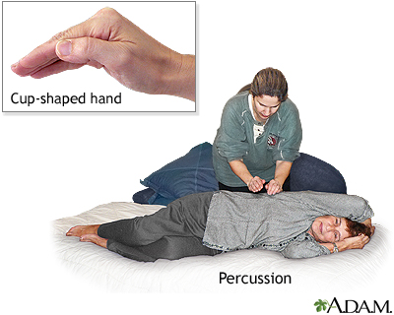
http://www.nlm.nih.gov/medlineplus/ency/patientimages/000266.htm
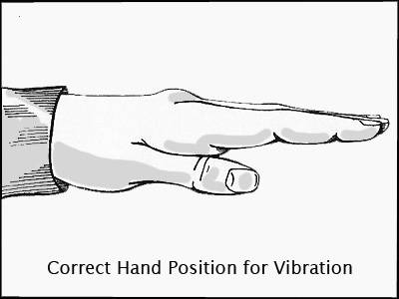
14.1D – Chest wall vibration hand position

http://copd.about.com/od/copdtreatment/ig/Postural-Drainage-Positions/Vibration-Hand-Position.htm
14.1E – Active cycle of breathing technique

14.1F – Rebound Therapy photograph
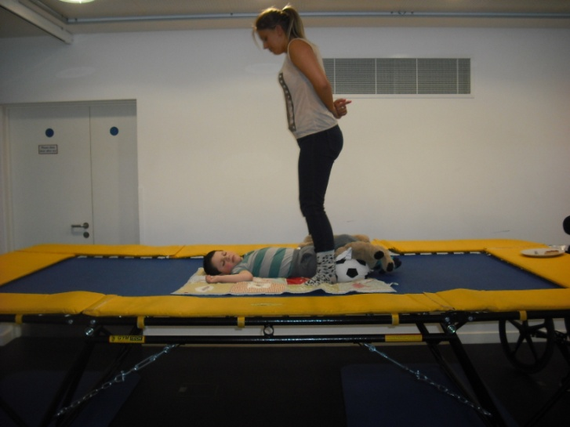

14.1G – Wedge positions for chest physiotherapy
Prone
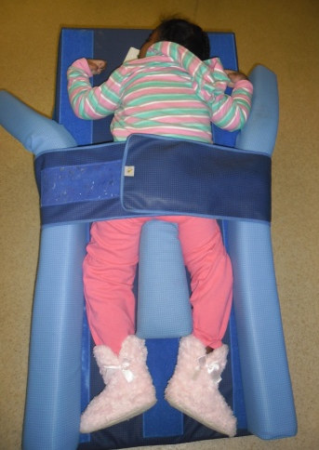
Left and right side lying
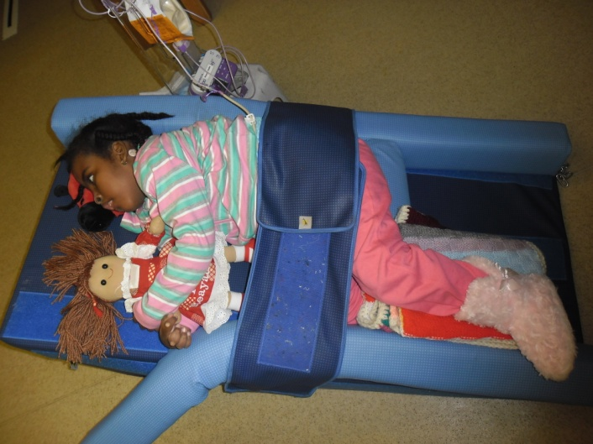

Supine
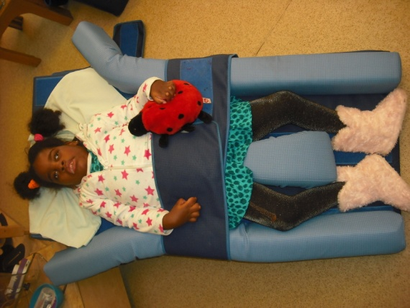
14.1H – Rebound therapy positions for chest physiotherapy
Prone
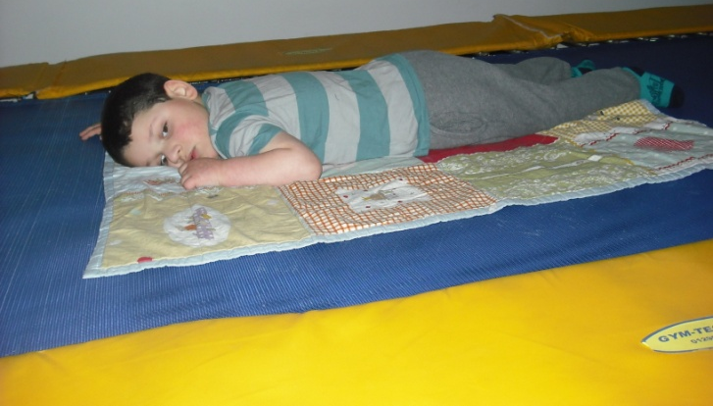
Left and right side lying
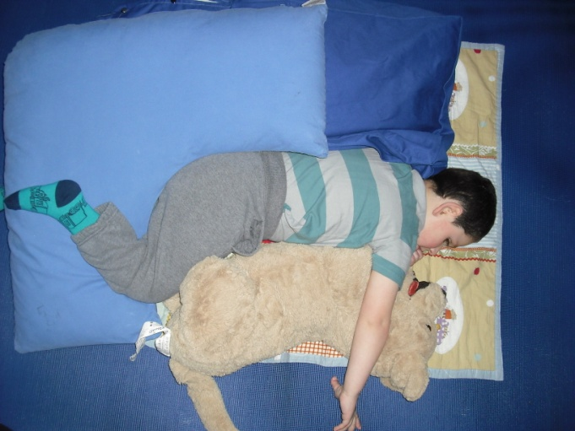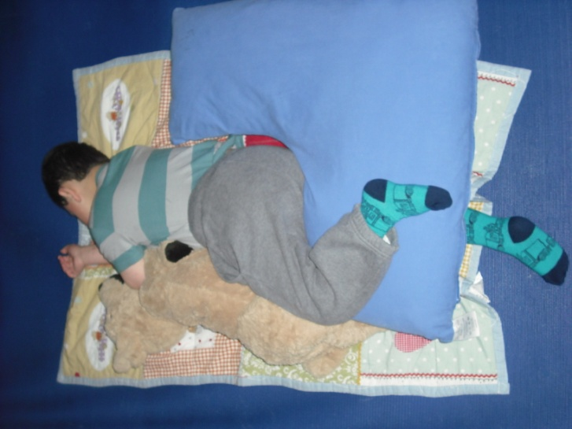
Supine
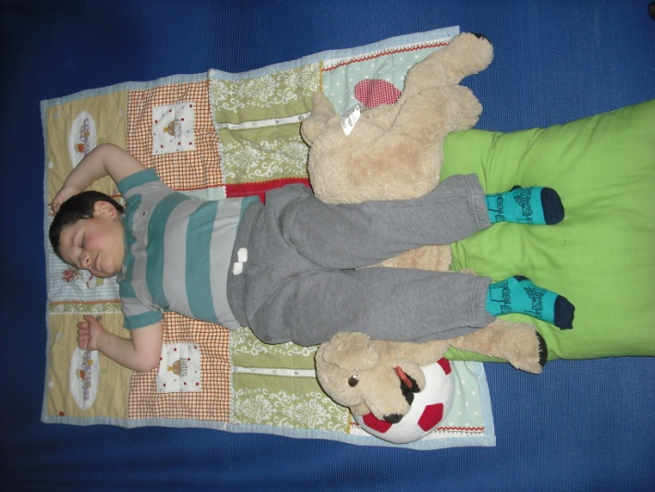
14.1I – Suction machine picture
Portable Suction Machine

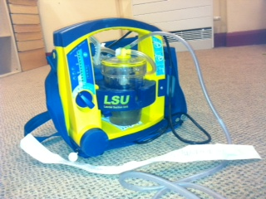

Pressure gage Catheter

